A Christmas Novena

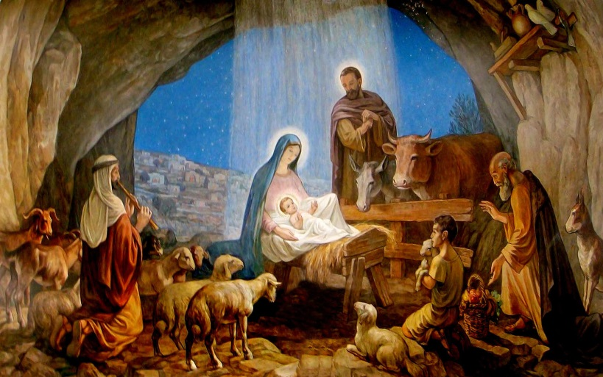
For the 9 Days before Christmas

One of the best things about celebrating a Catholic Christmas are the final days leading up to Christmas Eve. The tradition of praying a novena for the nine days leading up to Christmas Eve is an important thing is to prepare our hearts for the coming of our savior, Jesus Christ. This Christmas Novena is nice because it uses the biblical titles of Jesus that correspond with the O Antiphons that appear in the Liturgy of the Hours on the final eight days before Christmas.
Pray this novena daily from December 16 to Christmas Eve.
A Christmas Novena
December 16:
O Shepherd that rulest Israel, Thou that leadest Joseph like a sheep, come to guide and comfort us.
Recite one Our Father, one Hail Mary, and one Glory be.
December 17:
O Wisdom that comest out of the mouth of the Most High, that reachest from one end to another, and orderest all things mightily and sweetly, come to teach us the way of prudence!
Recite one Our Father, one Hail Mary, and one Glory be.
December 18:
O Adonai, and Ruler of the house of Israel, Who didst appear unto Moses in the burning bush, and gavest him the law in Sinai, come to redeem us with an outstretched arm!
Recite one Our Father, one Hail Mary, and one Glory be.
December 19:
O Root of Jesse, which standest for an ensign of the people, at Whom the kings shall shut their mouths, Whom the Gentiles shall seek, come to deliver us, do not tarry.
Recite one Our Father, one Hail Mary, and one Glory be.
December 20:
O Key of David, and Sceptre of the house of Israel, that openeth and no man shutteth, and shutteth and no man openeth, come to liberate the prisoner from the prison, and them that sit in darkness, and in the shadow of death.
Recite one Our Father, one Hail Mary, and one Glory be.
December 21:
O Dayspring, Brightness of the everlasting light, Son of justice, come to give light to them that sit in darkness and in the shadow of death!
Recite one Our Father, one Hail Mary, and one Glory be.
December 22:
O King of the Gentiles, yea, and desire thereof! O Corner-stone, that makest of two one, come to save man, whom Thou hast made out of the dust of the earth!
Recite one Our Father, one Hail Mary, and one Glory be.
December 23:
O Emmanuel, our King and our Law-giver, Longing of the Gentiles, yea, and salvation thereof, come to save us, O Lord our God!
Recite one Our Father, one Hail Mary, and one Glory be.
December 24:
O Thou that sittest upon the cherubim, God of hosts, come, show Thy face, and we shall be saved.
Recite one Our Father, one Hail Mary, and one Glory be.

