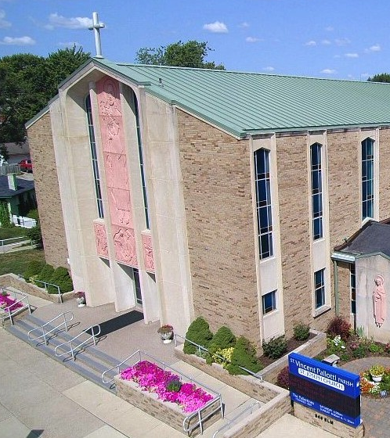
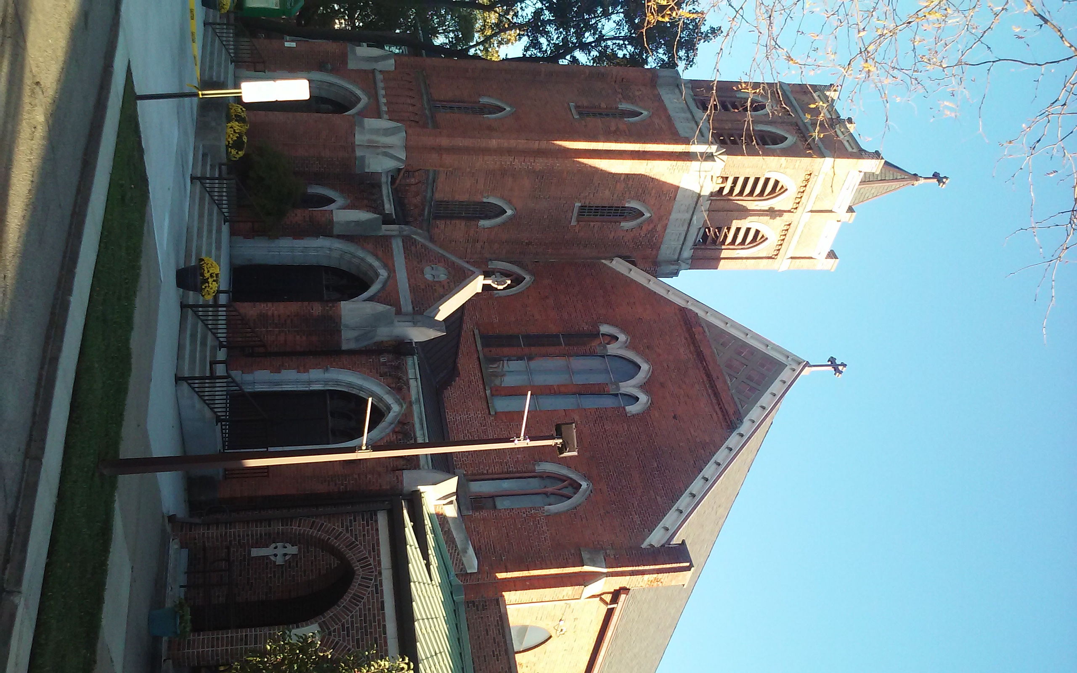
St. Vincent Pallotti Parish
With the churches of St. Joseph and St. Patrick
Wyandotte, Michigan

Marriage
Guidelines

Please review these guidelines as soon as possible and make sure you mark your calendar. You are responsible for these deadlines as you get closer to your wedding date. Questions? Call the Parish Office at 734-285-9840, ext. 100.

Priest interview
This should be done at least six months in advance of when you wanted to get married and before you secure your hall for the reception. At the meeting, your marriage date will be discussed and scheduled in the parish calendar and church of your choice. (Either St. Joseph or St. Patrick Church). During this initial interview, the priest will also explain the parish policies concerning the formation time, fill out the required paperwork, prepare any dispensation papers, etc.

Marriage Preparation Class
You will be required to attend a marriage preparation class before you can marry in the church. St. Vincent Pallotti Parish currently does not offer classes, but recommends the program offered through St. Frances Cabrini Parish in Allen Park. The current retreat dates are in your yellow folder. You can also go to www.cabriniparish.org and click on “Pre Cana Retreat”. Call St. Frances Cabrini at 313-381-5601 if you have any questions. If you cannot attend the workshops at Cabrini, the Archdiocese of Detroit has other options available. Please visit their website at: www.aodonline.org.

Pre-Marriage Inventory (PMI)
In addition to the preparation classes, you will be sent via email a PMI to complete at least 3 months prior to your marriage. This is through the FOCCUS GROUP program and the email will be coming from them. If you DO NOT receive their email within three months of your wedding date, check your spam folder. Otherwise, please call the Parish Office at 734-285-9840, ext. 100.

Baptismal Certificates
If you were baptized at St. Joseph, St. Patrick, St. Elizabeth or St. Vincent Pallotti Parish, a certificate will not be necessary as your record will be in our files. You will need to get a certificate if you were baptized at another parish, and it must be dated no more than six months prior to your scheduled marriage. If either couple was baptized in another faith, a copy of his or her baptism certificate will be needed.

Liturgy Details
You will receive a folder from the pastor with an information sheet, Scripture readings and Prayer of the Faithful petitions. This material will help you plan your wedding celebration and provide a guideline for the wedding coordinators. Friends or relatives, preferably one from each of the couple, may be chosen to do the readings and Prayers of the Faithful. Being of the Catholic faith is recommended for these readings.

Music – Call Kim Kilburn, our music director asap to secure your date, at 734-282-5882 or email her at kim.kilburn.music@gmail.com. Please note: If you are NOT contracting with our Director of Music, you must let Kim and the wedding coordinator know who is providing the music. This individual must be well versed in what is proper for the Catholic wedding liturgy.

Wedding ceremony options:

Unity Candle
The lighting of the two tapers and large pillar candle, signifying the unity of their families together in Christ. If you choose this tradition, you must provide the candles. Unity sand or cord is also an option.

Flower presentation to the Blessed Virgin Mary
Couples who have a devotion to Mary will take a moment before the conclusion of the liturgy to offer prayers and flowers to Mary as they begin their life together. Your florist will help you with this.

Decorations
Floral decorations, pew bows, etc., if desired, are your responsibility. Please only use ribbon to secure pew bows, no wire or tape. The florist or wedding coordinator may place these in church shortly before the time of your wedding. Due to safety concerns, aisle runners are not allowed in church.

Programs
You can provide a program to follow during your Wedding Mass. Bring them to the rehearsal so they can be set out before the wedding. Groomsmen can hand them out to your guests as they arrive.

Photography
The use of flash is forbidden during the ceremony. Video cameras are to be used discreetly with permission from the celebrant. Please be sure to check with the wedding coordinators for the appropriate placement of video cameras and boundaries for the photographer. The photographer should be inconspicuous and should never stand in front of the guests, in the pews or up by the Altar.

Receiving Line
There is no receiving line after a church service or Mass. This is something you can reserve for arriving at your reception.

Throwing Rice, Bird Seed, etc.
To avoid any hazard to safety and to minimize custodial work, the throwing of rice, confetti (both regular and biodegradable), rose petals, bird seed, bubbles or anything else (inside or outside of church) is prohibited at both worship sites. You will be billed for the clean-up if this is not followed.

Donations
Registered, active and contributing members of St. Vincent Pallotti Parish support the ongoing work and maintenance of the parish. A $250 donation to the Parish is mandated and secures your date. The $250 will go towards your offertory donation. If you have not been a registered, active and contributing member of the parish for at least one year prior to the scheduling of your marriage date, the fee is $500, $250 of which is due the day you book your wedding with the Pastor. If you have extenuating circumstances, please speak with the Pastor.

Rehearsal
Please call the Parish Office as soon as possible with the date you would like for your rehearsal. Times are usually 5:00 pm or 6:00 pm. Call 734-285-9840, ext. 100 to reserve your date.

Bride and Groom waiting rooms
We are happy to provide dressing / waiting rooms for the bride and groom before the wedding begins. Your wedding coordinator will show you these areas during your rehearsal.

Dress Etiquette for a Catholic Church
A bride marrying in a Roman Catholic Church should select a gown that is appropriate in style and color, and one that maintains tradition for the ceremony. The groom, also, must follow guidelines for proper attire.

The Bridal Gown
St. Vincent Pallotti Parish practices the guidelines set forth by the Catholic Church for the bride — and her bridesmaids — to cover their shoulders during the ceremony as a sign of respect and modesty. You may want to consider a shawl or lace jacket while in church that can later be removed for a strapless look later during the reception. If you have any questions, please call the Pastor or the Wedding Coordinator.

The Groom's Attire
The groom traditionally wears a tuxedo or suit and tie, dress shoes during the church service. Because the sacramental ceremony is a significant life event, it is important and respected to dress appropriately in a Catholic Church — no jeans, sneakers, sandals or sunglasses.

Please note:
Brides and bridesmaids should avoid plunging necklines and gowns that reveal too much cleavage. Skin-tight gowns and dresses cut above the knee are frowned upon. These kinds of dresses can call for an uncomfortable moment when the couple is asked to kneel or sit during prayer. Both the bride and groom should also make an effort to cover any tattoos and to remove any unconventional piercings — Again, while it is not required, it is considered a sign of respect for the Pastor and for the sanctity of the marriage and the Catholic Church. If you have any questions, please consult the Pastor.

Wedding Checklist
Please mark your calendar with these important dates!
If you have questions, call the Parish Office at 734-285-9840, ext. 100

- When you first meet with the priest - MARRIAGE GUIDELINE SHEET – We cannot stress enough how important it is to read through your guideline sheet. It contains valuable information and is crucial to planning for your wedding with the church.

- One year in advance – SECURE ORGANIST – Call Music Director, Kim Kilburn, after you secure your wedding date, so she can mark on her calendar. Even if you decide to use another organist, please give Kim a courtesy call to let her know. Her number is 734-282-5882 or email her at kim.kilburn.music@gmail.com.

- Within 1 year - MARRIAGE PREPARATION WORKSHOP – St. Frances Cabrini Parish host marriage workshops called “Pre Cana Retreats” throughout the year. Schedule your retreat as soon as possible. A registration sheet is in your folder or you can download at www.cabriniparish.org. The workshops are usually held in January, May and October.

- Within 6 months - BAPTISMAL CERTIFICATE - Request a copy (within 6 months of your marriage date) of your Baptismal certificate from your parish of baptism if other than St. Joseph Wyandotte, St. Patrick Wyandotte, St. Elizabeth Wyandotte or St. Vincent Pallotti Parish). Bring a copy to the Parish Office or have the church where you were baptized mail it to us at: St. Vincent Pallotti Parish, 334 Elm Street, Wyandotte, MI 48192, Attn: Office Manager.

- Within 3 months before wedding - PRE-MARRIAGE INVENTORY (PMI) - You will receive an email within 3 months of your wedding via the FOCCUS GROUP that will contain a series of questions. Once completed, the results are emailed to the Pastor for review. If you do not receive this email within 90 days, call the Parish Office at 734-285-9840, ext. 100.

- Within 3 months before wedding – SCHEDULE REHEARSAL– Rehearsals are 5:00 or 6:00 pm, 1 or 2 days before the wedding. Call the Parish Office at 734-285-9840, ext. 100.

- Within 30 days of your wedding – Apply for your MARRIAGE LICENSE – Apply for a license within 30 days of your wedding date. Apply at the County Building of either the bride or groom’s county of residence. For those who reside OUTSIDE the State of Michigan, apply for the License in Detroit at the Wayne County City Clerk’s office.

- 2 weeks prior to the wedding - INFORMATION SHEET – This is in your yellow folder, which you received from the Pastor. Please return to the Parish Office. If you need additional forms, visit www.stvpp.org under Sacraments / wedding planning.

- Within 1 week before wedding – Copies of MARRIAGE LICENSE - Bring all original copies of your marriage license to the Parish Office so we can prepare them for your wedding.

